CBF
CONSERVATIVE BUSINESS FORUM

The President and Officers of the CBF have pleasure in inviting you
to a Business Breakfast in The Perry Suite, Main Function Building
The Three Counties Showground, Malvern, WR13 6NW
On Friday 22nd July 2016 at 7.30 am. Finish by 10.30 am latest.
Our guest speakers are

Harriett Baldwin, MP for West Worcestershire
And Economic Secretary to The Treasury
Returned with an increased majority at the last General Election and now with Treasury responsibility, Harriett will share her post EU Referendum thoughts with us and what the implications are for both UK PLC and UK based businesses.

James O’Donnell B Sc., Technical Director, RIFT Technology
Cyber Security Consultant and Computer Network Specialist
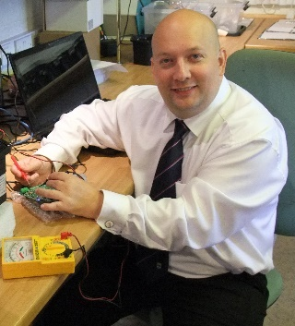
James is a graduate in Computing and Business Studies of Brunel University and Technical Director of a Malvern based computer network support company for the last 25 years. He has the perfect background and working knowledge to help us understand and cope with the threats to local business from Cyber Security issues and how to reduce them.

RSVP by 8th July please; by post, phone or email
WWCA, 209a, Worcester Road, Malvern Link, Worcs. WR14 1SP
Tel: 01684 573 469 Email: Office@wwca.org.uk
Breakfast £25 per head. Cheques payable to WWCA in advance or pay at the event.
Please feel free to bring along a guest, partner or colleague. West Worcestershire CBF welcomes everyone in business or interested in business and of any political persuasion or of none.

